

**Digital Logic Lab Assignment # 9**

* To design BCD to excess 3 code converter

**Submitted By**

Gaurav Chaulagain

Year I / SEM I

017BSCIT014

**Submitted To**

Signature Remarks

Er. Rajan Karmacharya

Lecturer, Dept. of Computer Science

Er. Saugat Sigdel

Lecturer, Dept. of Computer Science

Objective 1: To convert binary BCD to Excess Three.

**Theory:**

Binary coded decimal (BCD) is a system of writing numerals that assigns a four-digit [binary](http://searchcio-midmarket.techtarget.com/definition/binary) code to each digit 0 through 9 in a decimal (base-10) numeral. The four-[bit](http://searchcio-midmarket.techtarget.com/definition/bit) BCD code for any particular single base-10 digit is its representation in binary notation, as follows:

0 = 0000

1 = 0001

8 = 1000

Excess-3 equivalent of a decimal number is obtained by adding 3 and then converting it to a binary format. For instance to find excess-3 representation of decimal number 4, first 3 is added to 4 to get 7 and then binary equivalent of 7 i.e. 0111 forms the excess-3 equivalent.

0 = 0011

1 = 0100

3 = 0110

8 = 1011

9 = 1100

**Boolean Expression:**

**W = A + B(C+D)**

**X= B + (C+D)**

**Y = C . D**

**Z = D ‘**

**Block Diagram:**

**BCD to Excess 3**

**A W**

**B X**

**C Y**

**D Z**

**Circuit Diagram:**

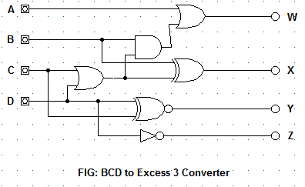

**Truth Table:**

|  |  |  |  |  |  |  |  |  |
| --- | --- | --- | --- | --- | --- | --- | --- | --- |
|  | **INPUT** | | | | **OUTPUT** | | | |
|  | **A** | **B** | **C** | **D** | **W** | **X** | **Y** | **Z** |
| 0 | 0 | 0 | 0 | 0 | 0 | 0 | 1 | 1 |
| 1 | 0 | 0 | 0 | 1 | 0 | 1 | 0 | 0 |
| 2 | 0 | 0 | 1 | 0 | 0 | 1 | 0 | 1 |
| 3 | 0 | 0 | 1 | 1 | 0 | 1 | 1 | 0 |
| 4 | 0 | 1 | 0 | 0 | 0 | 1 | 1 | 1 |
| 5 | 0 | 1 | 0 | 1 | 1 | 0 | 0 | 0 |
| 6 | 0 | 1 | 1 | 0 | 1 | 0 | 0 | 1 |
| 7 | 0 | 1 | 1 | 1 | 1 | 0 | 1 | 0 |
| 8 | 1 | 0 | 0 | 0 | 1 | 0 | 1 | 1 |
| 9 | 1 | 0 | 0 | 1 | 1 | 1 | 0 | 0 |

|  |  |  |  |  |
| --- | --- | --- | --- | --- |
| AB\CD | 00 | 01 | 11 | 10 |
| 00 | **0** | **1** | **1** | **1** |
| 01 | **1** | **0** | **0** | **0** |
| 11 | **X** | **X** | **X** | **X** |
| 10 | **0** | **1** | **X** | **X** |

**K-Map Representation:**

|  |  |  |  |  |
| --- | --- | --- | --- | --- |
| AB\CD | 00 | 01 | 11 | 10 |
| 00 | **0** | **0** | **0** | **0** |
| 01 | **0** | **1** | **1** | **1** |
| 11 | **X** | **X** | **X** | **X** |
| 10 | **1** | **1** | **X** | **X** |

**K-Map for W K-Map for X**

**W = A + B(C+D) X= B + (C+D)**

|  |  |  |  |  |
| --- | --- | --- | --- | --- |
| AB\CD | 00 | 01 | 11 | 10 |
| 00 | **1** | **0** | **1** | **0** |
| 01 | **1** | **0** | **1** | **0** |
| 11 | **X** | **X** | **X** | **X** |
| 10 | **1** | **0** | **X** | **X** |

|  |  |  |  |  |
| --- | --- | --- | --- | --- |
| AB\CD | 00 | 01 | 11 | 10 |
| 00 | **1** | **0** | **0** | **1** |
| 01 | **1** | **0** | **0** | **1** |
| 11 | **X** | **X** | **X** | **X** |
| 10 | **1** | **0** | **X** | **X** |

**K-Map for Y K-Map for Z**

**Y = C . D Z = D ‘**

**Observation:**

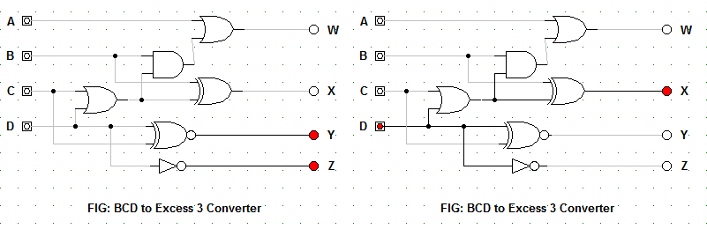

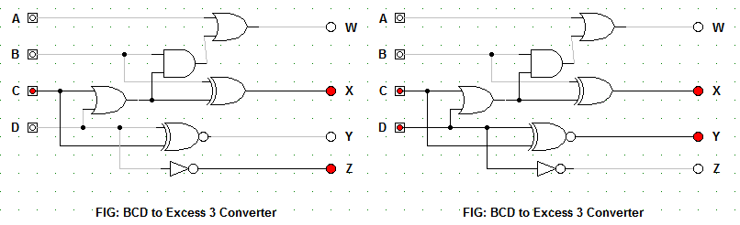

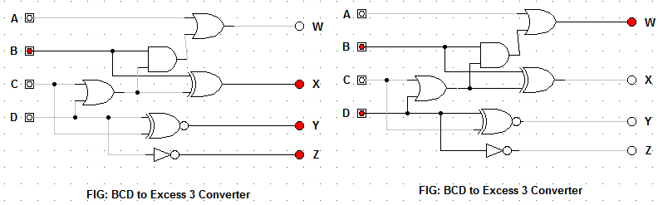

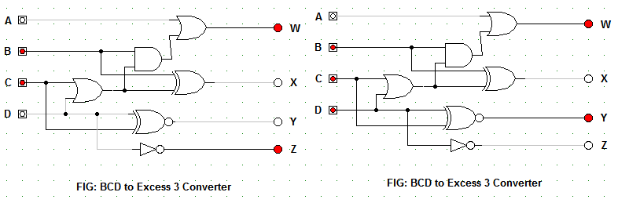

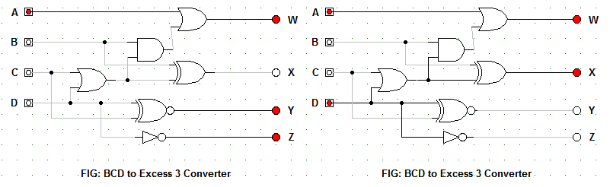

**Observation Table:**

|  |  |  |  |  |  |  |  |  |
| --- | --- | --- | --- | --- | --- | --- | --- | --- |
|  | **INPUT** | | | | **OUTPUT** | | | |
|  | **A** | **B** | **C** | **D** | **W** | **X** | **Y** | **Z** |
| 0 | 0 | 0 | 0 | 0 | 0 | 0 | 1 | 1 |
| 1 | 0 | 0 | 0 | 1 | 0 | 1 | 0 | 0 |
| 2 | 0 | 0 | 1 | 0 | 0 | 1 | 0 | 1 |
| 3 | 0 | 0 | 1 | 1 | 0 | 1 | 1 | 0 |
| 4 | 0 | 1 | 0 | 0 | 0 | 1 | 1 | 1 |
| 5 | 0 | 1 | 0 | 1 | 1 | 0 | 0 | 0 |
| 6 | 0 | 1 | 1 | 0 | 1 | 0 | 0 | 1 |
| 7 | 0 | 1 | 1 | 1 | 1 | 0 | 1 | 0 |
| 8 | 1 | 0 | 0 | 0 | 1 | 0 | 1 | 1 |
| 9 | 1 | 0 | 0 | 1 | 1 | 1 | 0 | 0 |

**Conclusion:**

Hence, the binary BCD code is converted to excess 3.

**Reference:**

1. **Binary Coded Decimal**

<http://whatis.techtarget.com/definition/binary-coded-decimal>